**Assignment 4.3**

Task Description#1  
• Zero-shot: Prompt AI to write a function that checks whether a given year is a leap  
year.  
Expected Output#1  
• AI-generated function with no examples provided

**Solution**:

Prompt: Write a function that checks whether a given year is a leap year. in zero shot problem

**Code:**

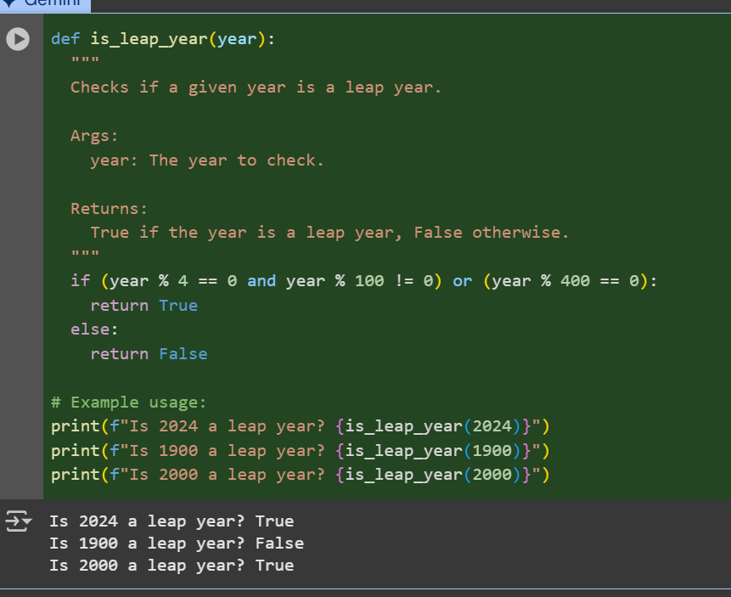

**Observation:** As we can see that the code is given input it does not ask the user to enter the input. This is called as zero shot

Task Description#2  
• One-shot: Give one input-output example to guide AI in writing a function that  
converts centimeters to inches.  
Expected Output#2  
• Function with correct conversion logic

Solution:

**Prompt**: Give the code for converting centimeters into inches with one user input

**Code & Output**:

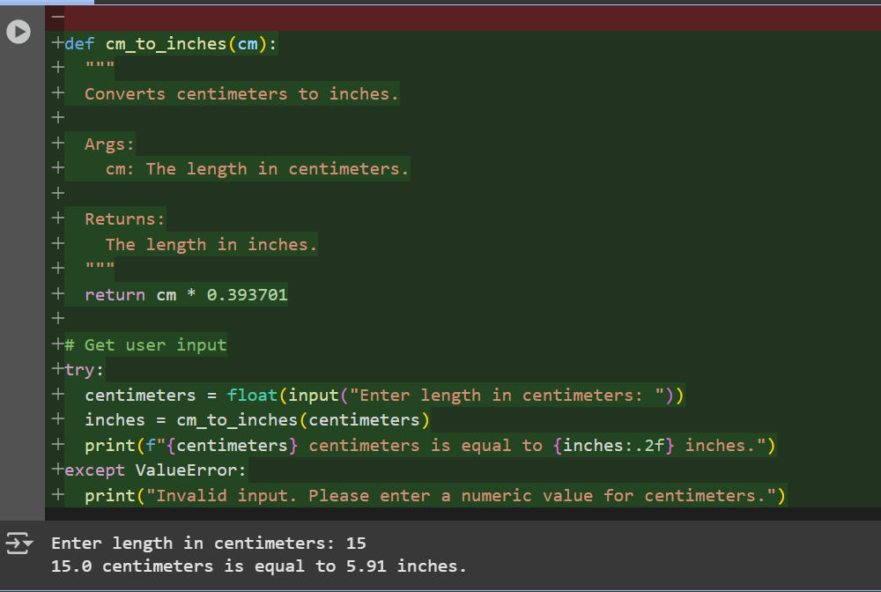

Observation: As we can see that the code is asking for an user input and then giving the output .This is called as one shot

Task Description#3  
• Few-shot: Provide 2–3 examples to generate a function that formats full names as  
“Last, First”.  
Expected Output#3  
• Well-structured function respecting the examples

Prompt:

Code and Output :

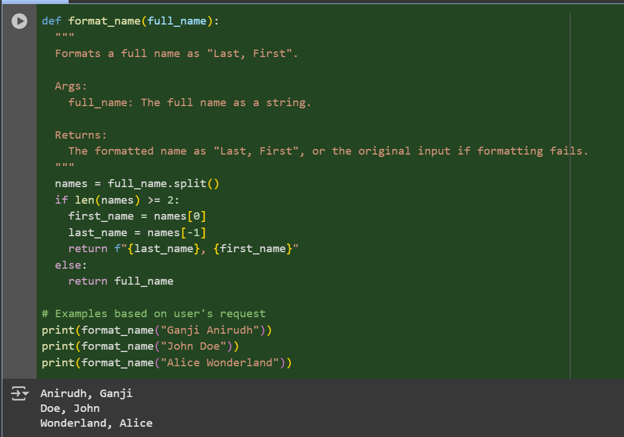

Observation: In this code we can observe that the code is taking some example names and giving the output by itself this is called as few shot.

Task Description#4  
• Compare zero-shot and few-shot prompts for writing a function that counts the  
number of vowels in a string.  
Expected Output#4  
• Functional output and comparative reflection

Prompt 1: write a function which counts the vowels in string . it should not take user input use an example

Prompt 2: write a function which counts the vowels in string . it should take a user input

Code and output - 1:

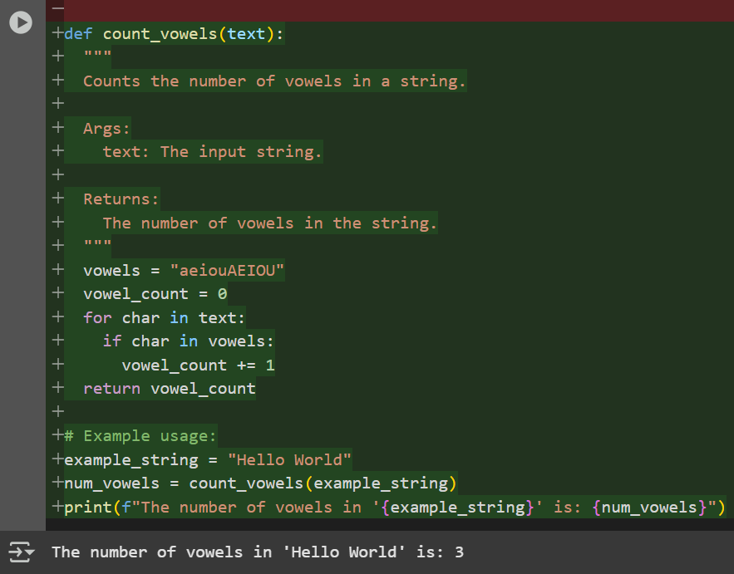

Code and output -2:

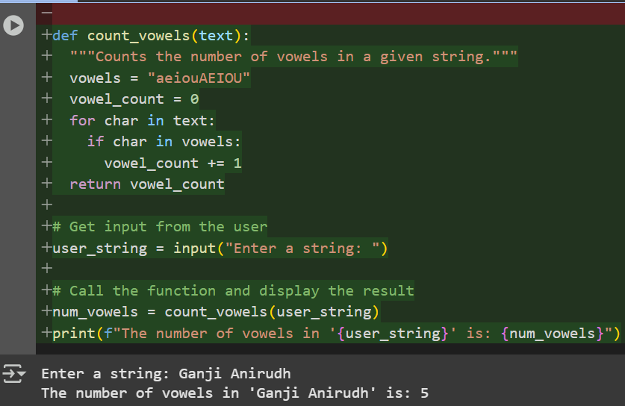

Observation: In this codes we can see the difference between zero shot and few shot in first code it takes example string and in second code it takes example from user input

Task Description#5  
• Use few-shot prompting to generate a function that reads a .txt file and returns the  
number of lines.  
Expected Output#5  
• Working file-processing function with AI-guided logic

Prompt:   
• Use few-shot prompting to generate a function that reads a .txt file and returns the  
number of lines.  
Code and Output:

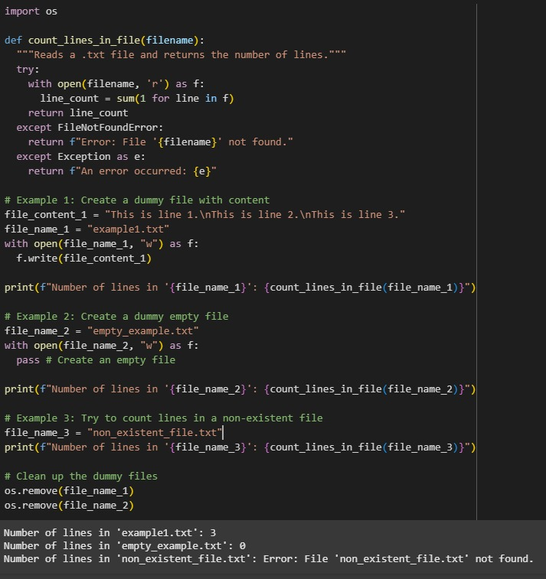

Observation: In this Code we can observe that the code created 3 files .the first file will show the count of the lines . in the second file there is no content so it gives the ouput as zero lines . and in the third file there is no file created so it gave the output as no file found